

Marmara University, Faculty of Engineering
Computer Engineering Department

CSE3038 – Computer Organization
Programming Project 1 - Project Report

Ayşe Sena AYDEMİR - 150119735
Emre Cihan VARLI – 150119711
Mustafa Can SEZER – 150119775

- Question 1
Overview
For this question, we wrote a MIPS program that turns a string into a palindrome by adding the fewest possible characters to the beginning. Our program takes user input, processes it, and shows both the resulting palindrome and how many characters we had to add.
Our Approach
We tackled this problem using the following strategy:
- First, we check if the input string is already a palindrome (if so, we're done!)
- If not, we need to find the longest part at the beginning of the string that's already a palindrome
- Then we calculate how many characters we need to add (original length minus the palindromic prefix length)
- Finally, we create the palindrome by:
  - Taking characters from the end of the string in reverse order
  - Adding them to the beginning of the original string
Main Procedures We Implemented
is_palindrome This procedure simply checks if a string is already a palindrome by comparing characters from both ends and moving inward.
- Input: $a0 = address of string
- Output: $v0 = 1 if it's a palindrome, 0 if not
find_shortest_palindromic_prefix This is the key procedure that finds the longest prefix that's also a palindrome. This helps us minimize how many characters we need to add.
- Input: $a0 = address of string, $a1 = length of string
- Output: $v0 = length of longest palindromic prefix
strlen Just counts the length of a null-terminated string.
- Input: $a0 = address of string
- Output: $v0 = length of string
remove_newline A helper function that removes the newline character from input strings.
- Works directly on the input_str buffer
Memory Management
We used these data segments:
- input_str: Buffer for storing user input (100 bytes)
- palindrome: Buffer for storing our palindrome result (200 bytes)
Key Registers
- $s0: Stores the original string length
- $s1: Stores the length of the longest palindromic prefix
- $s2: Stores the number of characters we need to add
- $s3: Stores the address of the palindrome buffer
- $t0-$t5: Used for temporary calculations and loop control
Following Conventions
We made sure to follow proper MIPS conventions:
- Using $a0-$a3 for passing arguments
- Preserving all argument registers across procedure calls
- Using the stack properly to save and restore registers
- Returning values in $v0
Edge Cases We Handled
- If the input is already a palindrome, we don't add any characters
- If we can't find a palindromic prefix (except the first character), we default to a prefix length of 1
- We automatically remove newline characters from input
Screenshots
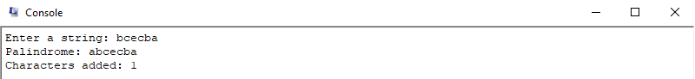
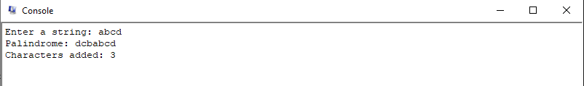
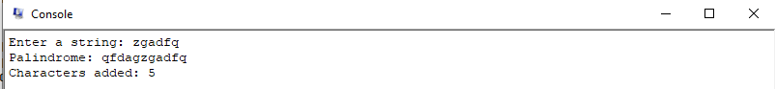
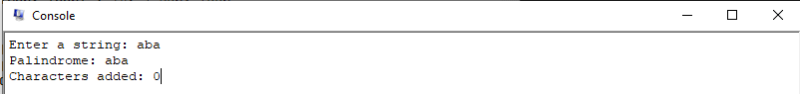

- Question 2
Overview
For this question, we created a MIPS program that finds the Nth maximum unique number in an integer array. Our program takes user input for both the array elements and N, then outputs the Nth maximum after removing any duplicate values. If N is larger than the number of unique values, we just return the maximum number.
Key Components
Input Processing: We read a line of space-separated integers and parse them into an array. We did this by processing each character, converting ASCII characters to integer values. Our parsing can handle multiple spaces between numbers and stops properly at newlines.
Sorting: We implemented a bubble sort to arrange the array in descending order. It's not the fastest sorting algorithm, but it works well for this assignment and is straightforward to implement. The sort uses nested loops to compare adjacent elements and swap them when needed.
Removing Duplicates: After sorting, we go through the array to extract just the unique values. Since the array is already sorted, identical values appear next to each other, making them easy to spot. We make a single pass through the sorted array and copy unique values to a separate array.
Finding the Nth Maximum: Since our array is already sorted in descending order with no duplicates, the Nth maximum is simply the (N-1)th element (because arrays start at 0). We also handle cases where N is too large by returning the maximum value and indicating that the requested N wasn't valid.

Memory and Register Management: We carefully followed MIPS conventions:
- Passing arguments through $a0-$a3
- Preserving all argument register values
- Using $v0 for return values (and $v1 for validity flags)
- Allocating stack space properly for local variables and register preservation
Error Handling
We assumed all inputs would be valid positive integers as specified in the assignment. For the specific case where N exceeds the count of unique values, we return the maximum value instead, which satisfies the requirement.
Screenshots
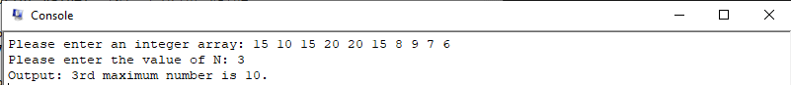
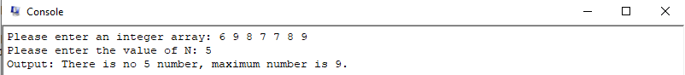
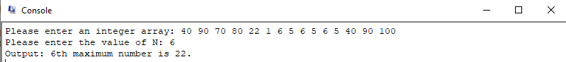

- Question 3
Overview
For this question, we wrote a MIPS program that checks password strength and suggests improvements for weak passwords. Our program evaluates passwords based on three main criteria:
- Length (must be longer than 6 characters)
- Character diversity (must include lowercase, uppercase, digits, and the special characters '*' and '+')
- No consecutive repeating characters

How We Structured the Program
We used a modular approach with separate procedures for different tasks:
- Main Procedure: Controls the overall flow, handles input/output, and coordinates the validation and suggestion process
- remove_newline: Gets rid of the trailing newline character from user input
- check_password: Checks all the required criteria and returns 1 for strong passwords, 0 for weak ones
- string_length: Counts the length of a null-terminated string
- contains_char_range: Checks if the string contains any character within a specified ASCII range
- contains_char: Checks if the string contains a specific character
- has_repeating_chars: Looks for consecutive repeating characters
- suggest_password: Creates an improved password suggestion if needed
Key Implementation Details
Password Validation We check each requirement separately:
- Use string_length to verify the password is longer than 6 characters
- Use contains_char_range to check for lowercase letters, uppercase letters, and digits
- Use contains_char to verify the presence of '*' and '+'
- Use has_repeating_chars to detect consecutive repeating characters
Password Suggestion Algorithm Our suggestion algorithm works in two steps:
- Remove repeating characters by creating a new password without consecutive duplicates
- Add missing components:
  - Add any missing character types (lowercase 'z', uppercase 'Z', digit '9', '*', '+')
  - For short passwords, add lowercase 'a' until we reach the required length
Known Issue
We discovered a flaw in our suggestion algorithm. When extending short passwords, we repeatedly add the character 'a' without checking if this creates new repeating character sequences. For example, with input "aA1*+", our program suggests "aA1*+aa", which violates the no-repeating-characters rule. We would fix this in a future version.

Register Management
We preserved all argument registers ($a0-$a3) by saving them to the stack at the beginning of each procedure and restoring them before returning, following consistent calling conventions throughout our program.
Error Handling
As specified in the requirements, we assumed valid input (non-empty strings without spaces) and didn't implement explicit error handling for invalid inputs.
Screenshots
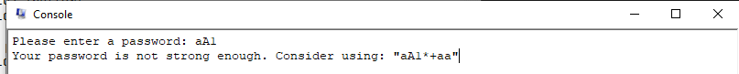
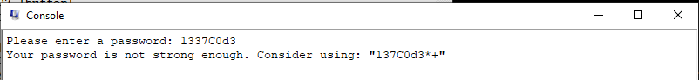
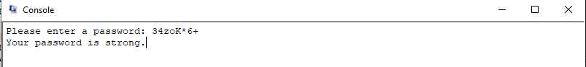
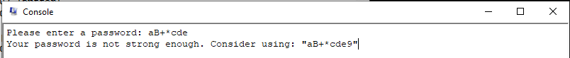
Question 4
We couldn't implement Question 4.

